**Implementation of different types of LAN topology with IP addressing using PT**

**Objectives:**

* Design the following topology in Packet Tracer.
* Subnet each of the network with the IP and complete the following table.
* Assign the appropriate IP into each of the network.
* Add one more PC to each of router and assign IP.
* Test connectivity between PC in a router.

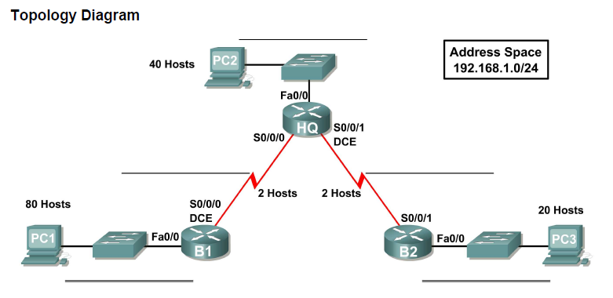

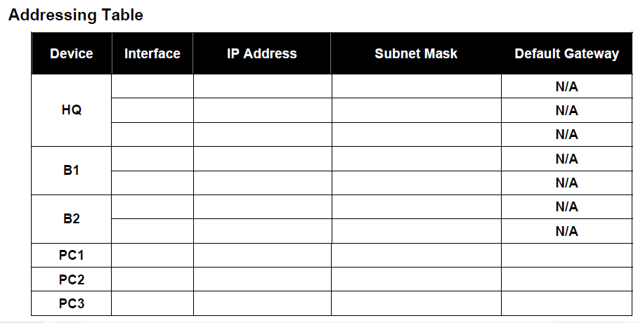

**Task 1: Perform Basic Router Configurations**

Perform basic configuration of the HQ router according to the following guidelines:

1. Configure the router hostname.

2. Configure an EXEC mode password.

3. Configure a message-of-the-day banner.

4. Configure a password for console connections.

5. Save the configuration

**Task2: Verify and Test the Configurations**

Step 1: Verify that routing tables have the following routes using the ***show ip route*** command:

Step 2: Verify interface configurations using the ***show ip interface brief*** command:

Step 3: Test the connectivity using ICMP and answer the following:

1. From PC1 to Router B1 (Successful/Fail) :
2. From PC2 to Router HQ (Successful/Fail) :
3. From PC3 to Router B2 (Successful/Fail) :
4. Router B1 to Router HQ (Successful/Fail) :
5. Router HQ to Router B2 (Successful/Fail) :
6. Router B1 to B2 (Successful/Fail) why? :
7. From PC1 to PC2 (Successful/Fail) why? :
8. From PC2 to PC3 (Successful/Fail) why? :
9. From PC1 to PC3 (Successful/Fail) why? :